MOC SAFEX Teams Events
By Thierry Rousse

TEXT
- ORIGIN of SAFEX Teams Events
The SAFEX Congresses in recent years took place in Helsinki in May 2017 and in Salsburg in May 2023. Unfortunately, the 2020 Congress had to be cancelled due to the COVID-19 pandemic.
Two SAFEX Webinar Events were initiated with the aim of maintaining connectivity among SAFEX members and further advocating for safety. Six Teams events have been successfully conducted, with the two most recent focusing on Management of Change.

- WHY MANAGEMENT OF CHANGE
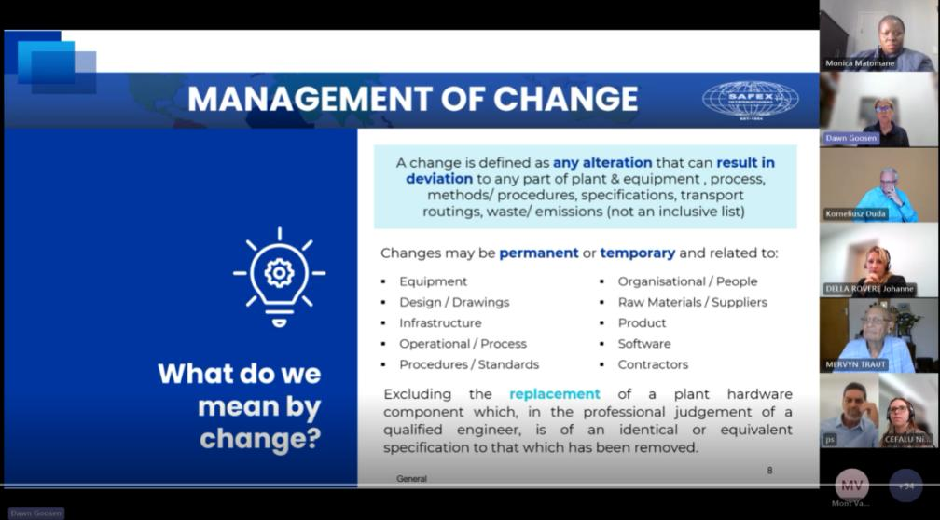
Change management is an integral aspect of a company's everyday operations. The constant need for a Business to adapt and grow presents a continual challenge. Irrespective of the nature of the change, its impact is undeniable.
The primary focus lies not in the CHANGE itself, as it is a relatively simple task, but rather in executing the CHANGE SAFELY, which presents a significantly greater challenge.
It is crucial to establish an effective change management system as many significant accidents are with a breakdown in the change management process.

Within each of our companies, there are instances of incidents that have occurred as a result of poorly managed change. Our objective is to disseminate this information within the SAFEX Community, pooling our resources to improve the safety performance of the SAFEX member companies.

- THE FORMAT OF THE MEETING
There have been two Webinars focused on change management:
- The first one was on 27th November 2023 (Webinar N°5)
- The second one was on 9th April 2024 (Webinar N°6)
The November 2023 event was centred on specific incidents that occurred as a result of inadequately managed change.
In April 2024, our aim was to enhance the participants engagement by transforming them into active contributors, rather than just passive consumers of the session.
In order to achieve success, it was essential to introduce a "user-friendly" format for participants, one that encouraged them to feel at ease, to engage and be actively involved in the webinar.
The team viewed the online meeting as being just like an in-person meeting, where it is easier to communicate in small groups.
Therefore, implementing a workshop incorporating the "Break out the rooms" function proved to be an excellent suggestion.

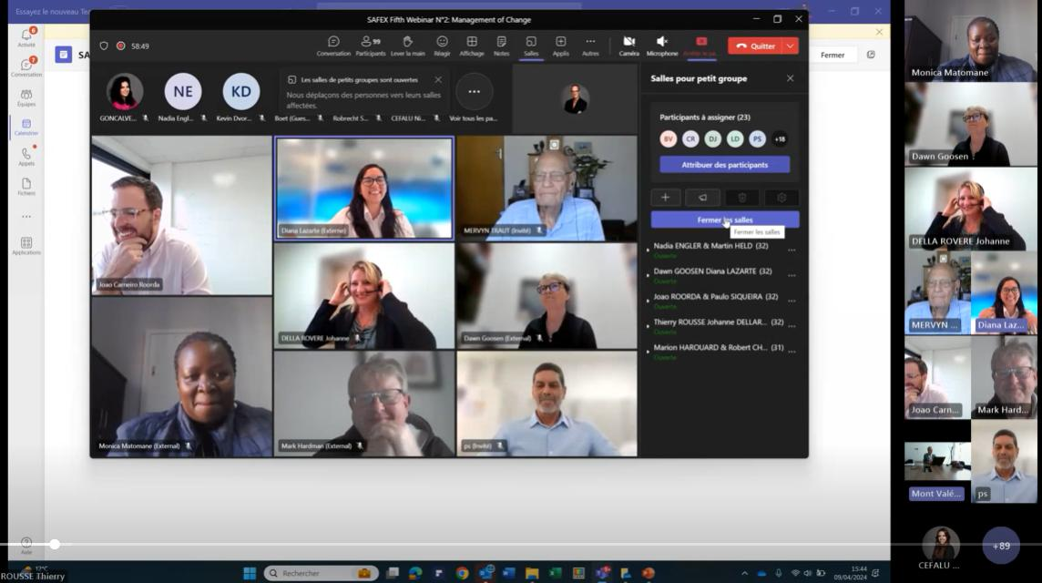
- A SPECIAL TEAM

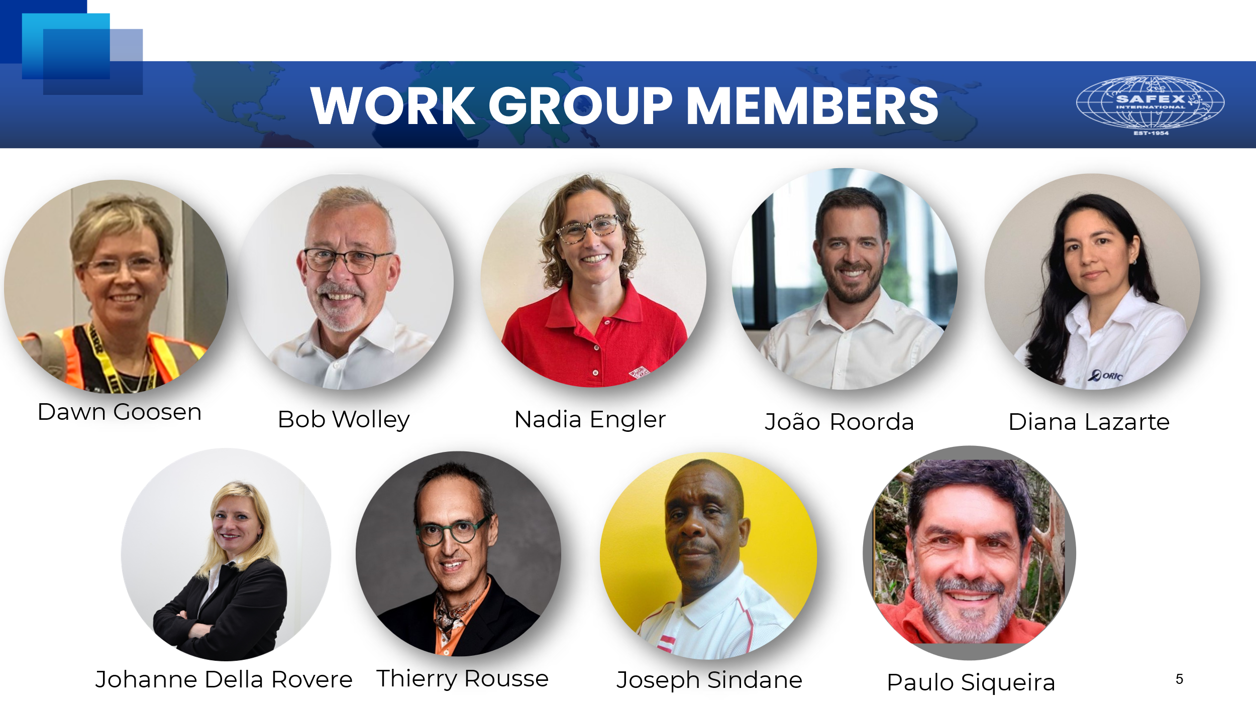

A highly efficient team was assembled, utilizing email communication and conducting six one-hour meetings. The team was provided with a dossier to facilitate collaborative and interconnected work.
The event was made possible due to its focus on the common objective of strengthening the MOC culture.
The diverse team, consisted of individuals from different continents, speaking various languages, with differing cultural backgrounds, and working for various companies, played a crucial role in presenting a unique proposition with an added advantage.
Experiencing a highly motivated and enthusiastic team working together to advance the MOC concept was truly remarkable. Their complete alignment with the SAFEX philosophy of promoting and advancing safety was evident.

- RESULTS
POSITIVE
- The meeting was conducted in a unique format that incorporated break out rooms, allowing for a more innovative approach.
- The breakout rooms were utilized effectively, resulting in excellent participation from all attendees.
- Our MOC WG team demonstrated commendable preparation for the meeting.
- The MOC chosen for the discussion was highly versatile, covering a wide range of topics.

FINDINGS
- The attendance for the "morning" session was lower with 114 participants compared to 147 who attended the corresponding session in November. However, the "afternoon" session saw better attendance with 34 participants compared to 26. A questionnaire has been circulated to gather feedback and make improvements for future sessions.

- NEXT STEP
- The working group recommends that an e-learning module is produced using available material.

