SafeTEAMS
Submitted by
Diana Ginnane

SafeTEAMS is the Dyno / Incitec Pivot Limited (IPL) global behavioural based safety program which provides a common language and common tools to take our safety culture to the next level. Our SafeTEAMS culture shows up through our language, beliefs, and actions.
The program is building the mindsets and skillsets needed to strengthen our Zero Harm culture (broader than just safety). Our leaders own their role as leaders in Zero Harm and demonstrate this daily through their actions and behaviours. By understanding the brain (its powers and limitations) our people can use it as one of our most valuable safety tools. We are creating the conditions to speak up, learn and contribute ensuring our teams are psychologically safe.
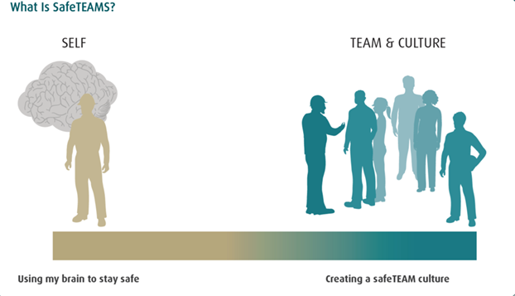
The content of the program draws on positive psychology and neuroscience informed learning concepts which are outlined in the table below:
Concept | Purpose | Language/Communication Examples
My Why | To personalise safety  To connect people to ‘Why’ they stay safe. | Share your personal commitment to safety… “My Why for safety is…”  To find out what motivates your team to stay safe.
Playing my Position | To reinforce personal and team accountabilities in your everyday activities and during organisational change. | How will we play our position?  What do we need and expect from each other?
Locus of Control (LOC) | To promote ownership and personal responsibility.  To identify what’s within your control during change. | What can we control or influence?  What brutal facts do we need to face?  How can we approach this with an Internal Locus of Control (ILOC) mindset?
SafeGROUND | To set the conditions  for psychological safety. To promote healthy challenge and idea sharing.  To promote diversity and inclusion. | How will we create SafeGROUND in this discussion?  What are we uncomfortable with?
BSAFE | To highlight the behaviours that underpin SafeGROUND. | Observe in Safe Act Observations (SAO), GEMBA’s - BSAFE and recognise it e.g. “It was great to see SafeGROUND in our conversation today” – outline what aspects you saw.  In team meetings encourage people to speak up and share different points of view.  Listen fully and ask questions – remember question to answer ratio.  Recognise and reward new ideas, different points of view and people who are willing to challenge the status quo.
Fast Brain and Slow Brain | To highlight how our brain balances efficiency and analysis particularly for managing hazards and risks. | Activities which require conscious (slow brain) versus subconscious (fast brain) thinking.  Use HALTS (Hungry, Angry, Late, Tired, Stressed) as a personal prestart reflection each day to recognise what affects our slow brain – therefore makes us more likely to miss hazards etc.  Take5 (IPL’s Personal hazard assessment), as an example, encourages slow brain. It is important to be self-aware of this so you can better manage the risk.
What Works Well?  Even Better If? | A rapid lessons learnt process or coaching tool. | What worked well?  What would be even better if?
Drift & Lift | To identify, correct and prevent drift.  To recognise and share better and safer ways of working- Lift. | Where is there a risk of performance drift? How will we hold the line and prevent drift?  Where have we seen lift in our performance culture?  What lift examples have you observed?
2 Degree Shift | To reinforce small shifts and individual commitments. | What 2-degree shift will you make?  What is one small change you could make?  Share your 2-degee shift with your team.
SafeTEAMS is more than just a one-day training program. It is an ongoing commitment to our safety culture. The completely refreshed behavioural based safety program was, designed, developed, and delivered internally with input into the design from all stakeholders across all levels of the organisation during 2020 and 2021. Training commenced in October 2021 and currently > 80% of our global workforce is now trained. We have been able to design and deliver a flexible training solution both virtually and face to face to support (with detailed facilitation material translated into all our company languages) the implementation during COVID-19 and significant travel restrictions.

Embedding tools have also been designed and developed to support implementation and to anchor the program across the organisation including posters, leadership field pocket cards, toolbox talks, conversation starters. a leader make it stick guide leader tip sheets, videos, and leader briefings.
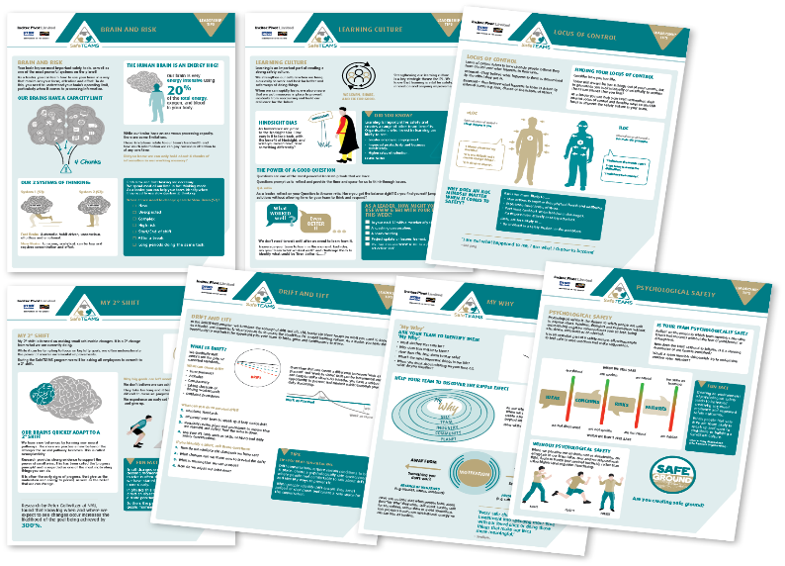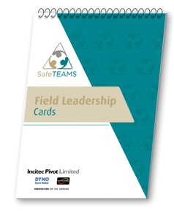
With the implementation of the global SafeTEAMs program there are a number of improvements that we are seeing across the organisation including;
Performance Improvement toward our Zero Harm Ambition
- Injuries that have resulted in serious harm have significantly decreased over the period.
- Over the last twelve months there has been a downward trend in TRIFR.
- Significant reduction in the number of actual Lost Workdays which demonstrates the effectiveness of our injury management process which focuses on early intervention strategies and engagement processes with our employees.
- There has been significant improvement in both process safety and environmental metrics in FY2022.
- Improved personal and process safety performance through maintaining operating discipline (addressing drift) with targeted and quality safety conversations.
Engagement
- SafeTEAMS as a common language is embedded across all levels and functions of the organisation including prestart meetings, toolbox talks, safety shares etc.
- Clear and defined linkages with other leadership, culture and diversity, and safety programs.
- Improved employee engagement with the development of key embedding tools. Leaders use the embedding tools provided to support increased visible and confident safety leadership in the field which has resulted in more effective and targeted safety conversations.
- Significant Event management is a performance measure to reflect Management’s focus on investigation, action close out and learning from events with high actual and potential HSE consequences. The total number of Significant Events has been consistent over the last three years which is a good indication of a strong reporting culture.
- Significant Events by Type – Hazard / Near Miss Ratio is also monitored. There has been an increase in Hazards and Near Misses (not just Incidents) being reported. This is also a measure of an improved reporting culture. Through increased visible safety leadership, we will continue to drive the reporting of Hazards and Near Misses. SafeGROUND supports a strong reporting culture.
- Significant Event Hazard Alerts and Lessons Learnt Bulletins (LLB) are utilised to improve engagement and distribution of learnings across the business. There has been significant improvement in Hazard Alerts and LLB's issued with the focus on our reporting culture.
- Our global 2022 / 2023 World Safety Day campaign which engages our employees across all levels of the organisation, embedded the SafeTEAMS common language.
- We will continue to connect SafeTEAMS into our ongoing HSE strategy, systems, language, processes, and future leadership programs.

Mentally Healthy Workplace
- Our SafeTEAMS and mental health and wellbeing programs are well aligned to create a mentally healthy workforce. Whilst SafeTEAMS provides the common language and the tools around behavioural safety and safety culture, our mental health and wellbeing program supports this through providing employees with concepts related to the “why” (e.g., purpose, values, beliefs) and the “how” (e.g., skills to engage in difficult conversations or creating SafeGROUND).
- We also continuing to build on a strong “care” culture through the concept of SafeGROUND (SafeTEAMS language for psychological safety). SafeGROUND helps to reduce the fear of reporting and raising issues including any safety concerns, including psychosocial hazards, and personal and mental health matters.
- SafeTEAMS and our mental health program language is consistent across delivery including in monthly topics, lunch and learns, resources and tip sheets, workshops, and mental health awareness and leadership training.
- Key SafeTEAMs concepts are linked in our mental health strategies e.g., Green Framing and Locus of Control (LOC) to promote mental health and wellbeing strategies which can be used in our everyday lives.
Through the implementation of the Dyno / IPL SafeTEAMS program, we can demonstrate a substantial and consistent improvement of workplace health, safety, and environmental performance. There has been increased efforts by the organisation to listen, engage and work with people to understand and address their concerns and expectations and demonstrate proactive efforts to improve mental health outcomes for employees.

